**Facebook Connector Deployment**

Prerequisites 2

Set up 2

Finalize 2

Reference 3

I. Download the package 3

II. Create AAD App 3

III. Storage account creation 8

IV. App service creation 14

V. Facebook App Registration 16

VI. Configure Connector 24

VII. Connector Setup in SCC 26

# Prerequisites

1. You need to have a Facebook account for your company pages. (This sample connector currently only allows importing data on your company’s Facebook business pages and not individual Facebook profiles.
2. You should have a valid Azure Subscription
   1. If you don’t have an existing Azure Subscription, you can either get
      1. Free subscription (valid for 1 year) [here](https://azure.microsoft.com/en-us/free/)
      2. Pay as you go subscription [here](https://azure.microsoft.com/en-us/pricing/purchase-options/pay-as-you-go/)

# Set up

1. Make sure the user who is setting up connector has Mailbox Import Export role.

For more information see the "Add a role in a role group" or the "Create a role group" sections in [Manage role groups](https://docs.microsoft.com/en-us/exchange/manage-role-groups-exchange-2013-help)

1. Ensure that you have accepted the consent by following the steps in the below link. Tenant admin has to click below link and log in with their credential.
   1. <https://login.microsoftonline.com/common/oauth2/authorize?client_id=570d0bec-d001-4c4e-985e-3ab17fdc3073&response_type=code&redirect_uri=https://portal.azure.com/&nonce=1234&prompt=admin_consent>
2. Ensure that you have an active Azure subscription as mentioned in Prerequisites point #2
3. Create AAD app using [Azure portal](https://portal.azure.com). Follow the below steps or refer Create AAD App with screen shots
   1. Azure Active Directory -> App Registrations -> New Application Registration Name of App : - i.e. FacebookConnector or any preferable name

Application type : - Web app / API

Sign on URL : - <https://portal.azure.com>

* 1. Register App and note **AAD APP ID**
  2. Go to app -> Settings -> Keys -> Fill Passwords details -> Save keys -> Copy **Password** value and save it to your secret location. This will be used when configuring the Connector.

1. Create storage account using [Azure portal](https://portal.azure.com). Follow the below steps or refer Storage account creation with screen shots
   1. Create a new Storage Account (Create a resource -> Storage -> Storage Account) -> Fill details -> Review & Create ->It will take some time)
   2. Go to Storage account created above -> Copy primary **connection string** and save it to a secret location. This will be used during deployment.
2. Create a Facebook developer App
   1. Refer screenshot Facebook App Registration or follow documentation on [Facebook developer portal](https://developers.facebook.com/docs/pages/getting-started/).

# Finalize

1. Download the builds of connector code and unzip it. It would have a single file
   * SampleConnector.zip
2. Deploy the web app in Azure
   * Follow the step as mentioned in App Service creation
   * Note your App Service URL required for Facebook App creation and Connector setup in SCC
3. Configure Login and Webhook products on Facebook developer portal
   * LoginUrl
     + <App Service URL>
   * RedirectUrl in Settings of Login product should be
     + <App Service URL>/Views/FacebookOAuth
   * SubscriptionUrl while setting up Webhooks product should be
     + <App Service URL>/api/FbPageWebhook
4. Go to SCC portal <https://protection.office.com>
5. Go to Data Governance > Import. and follow the onscreen steps. [Refer Screenshots here]

# Reference

## Download the package

Download the prebuilt package from repository’s Release section, <https://github.com/Microsoft/m365-sample-connector-csharp-aspnet/releases>.

## Create AAD App

#### Go to Azure portal, portal.azure.com

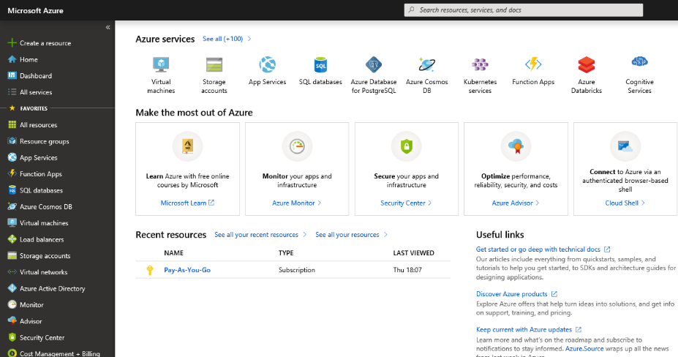

#### Go to Azure Active Directory

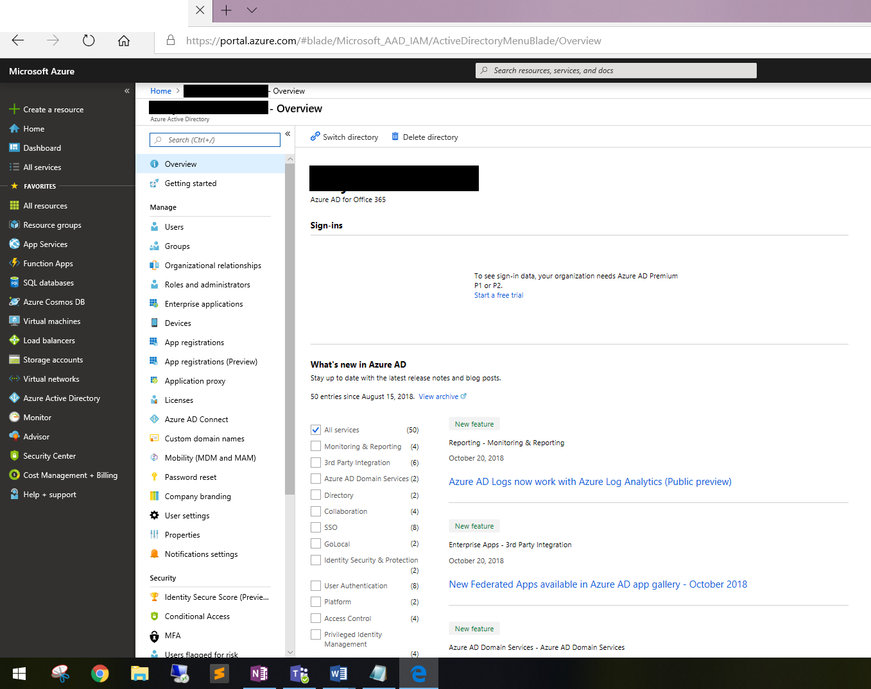

#### Go to App registration

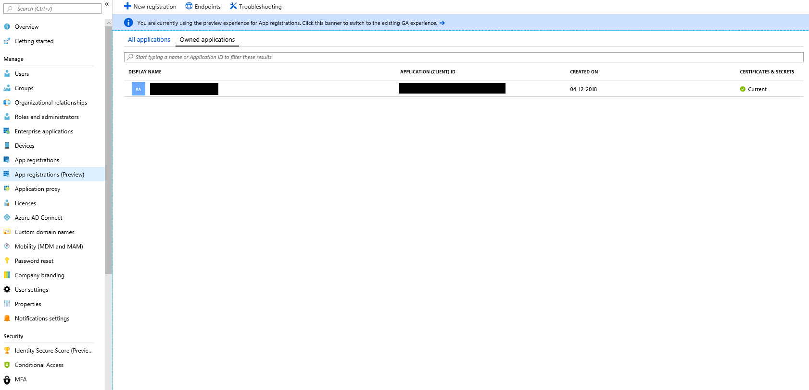

#### Register an App

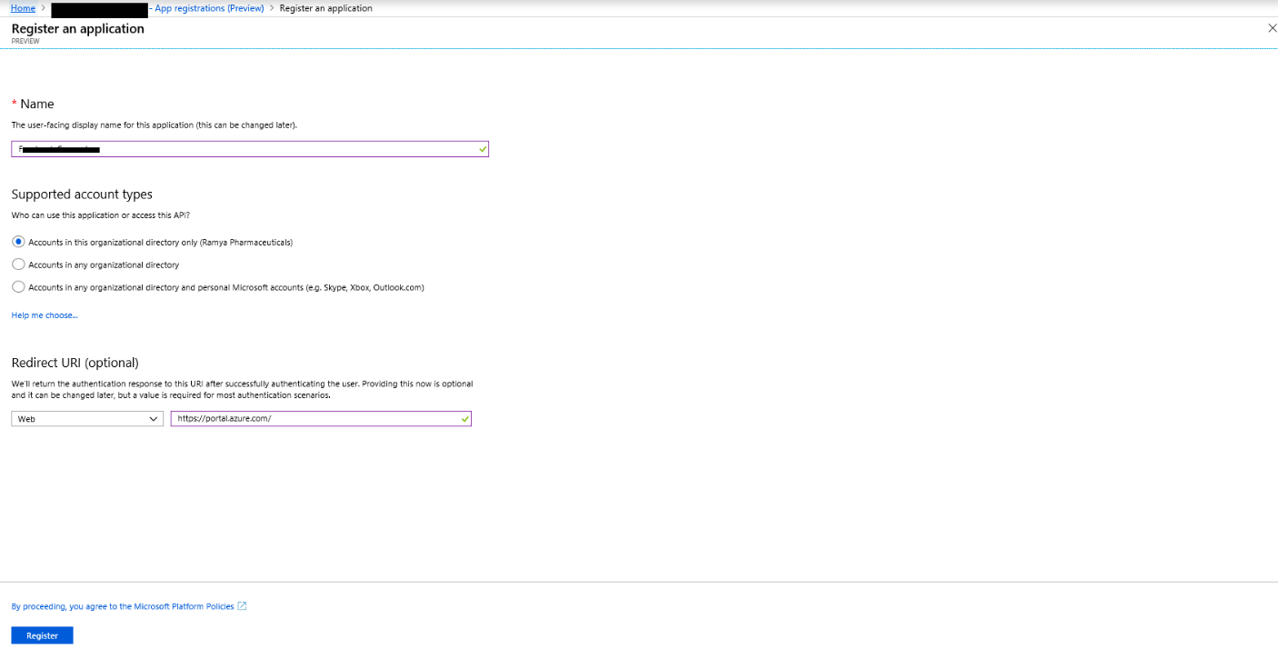

#### Make a note of the **AAD App Id**

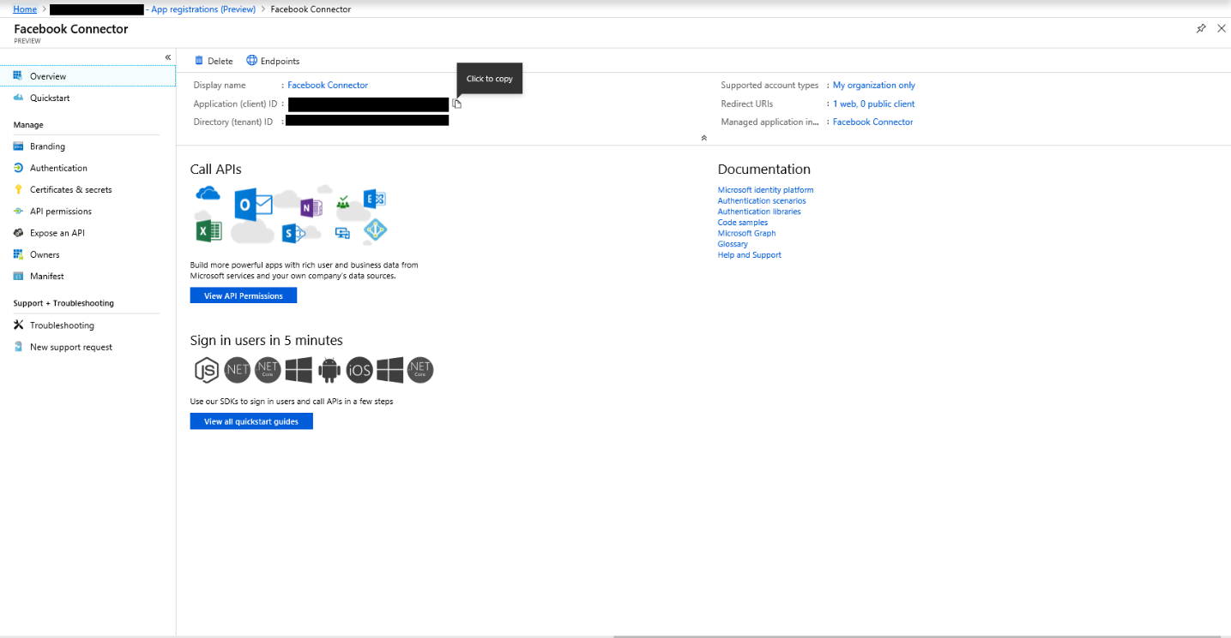

#### Go to Certificates and secrets

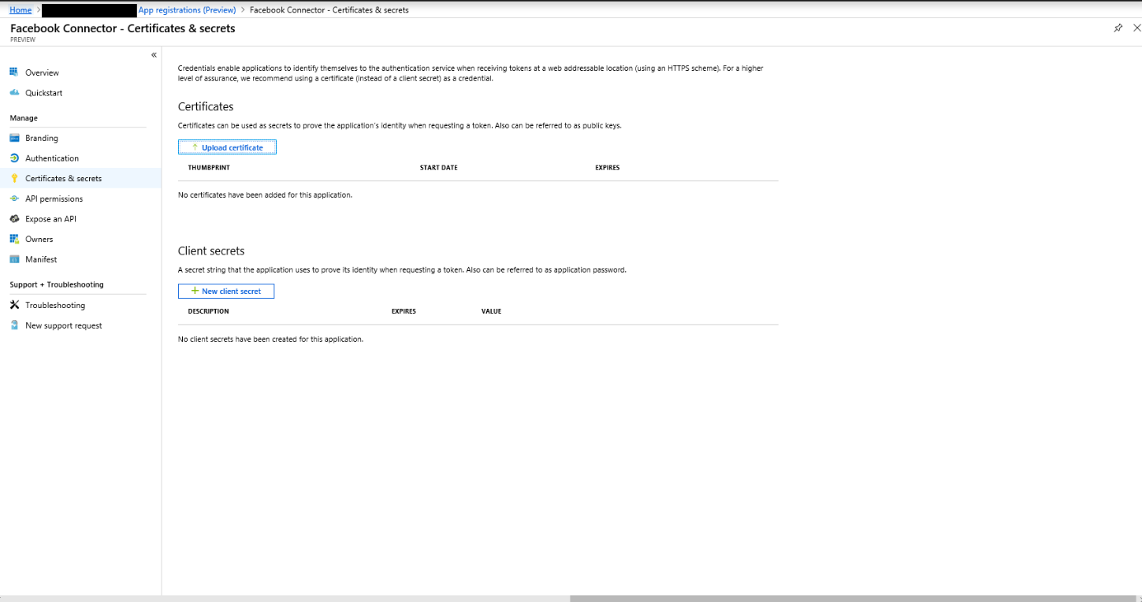

#### Click new client secret

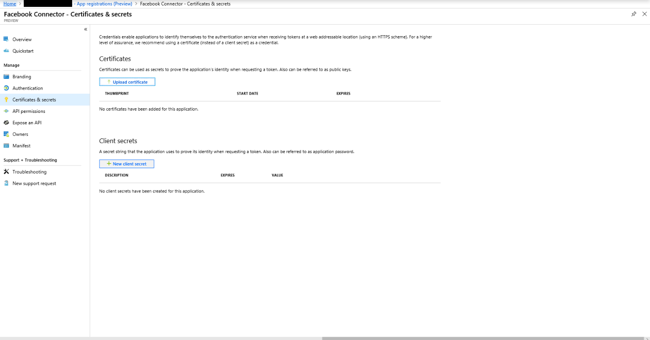

#### Create new secret

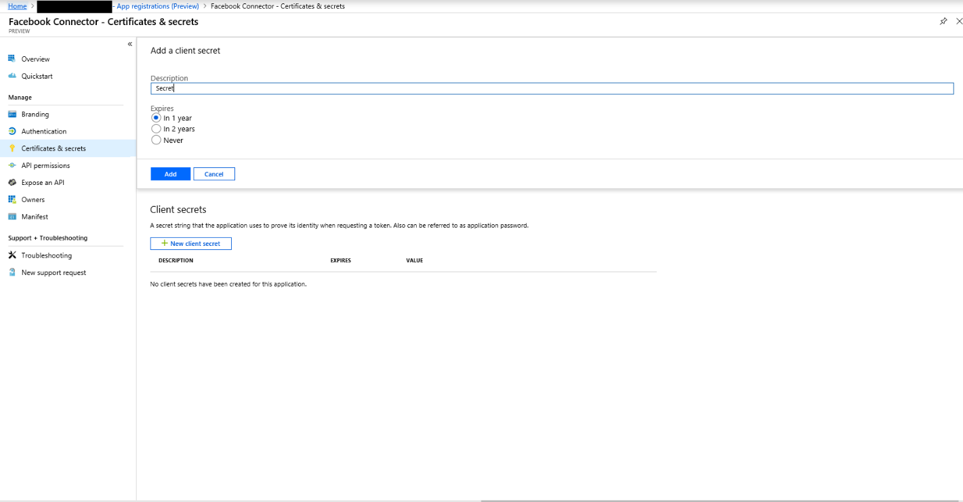

#### Make a note of the secret

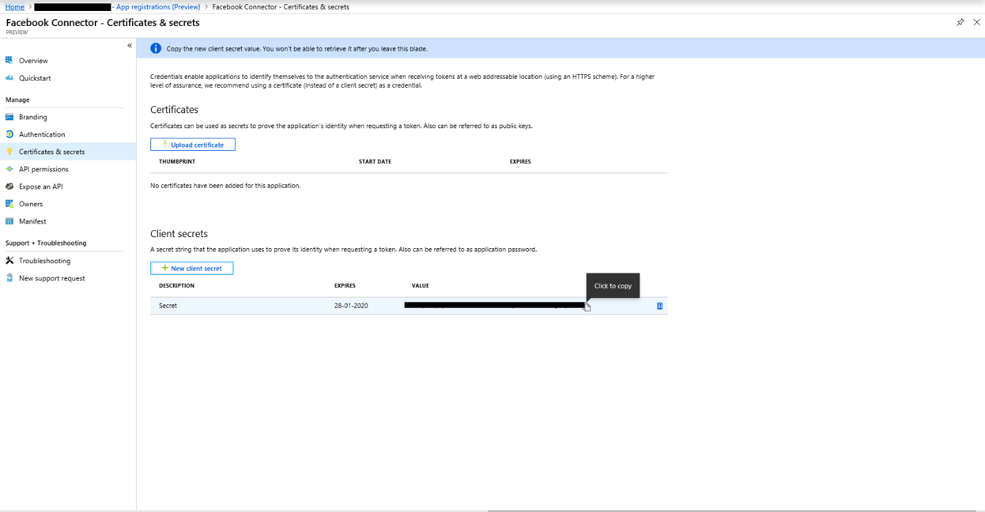

#### Go to Manifest-> Make a note of the identifierUris [Also called app id uri] as highlighted in the below image

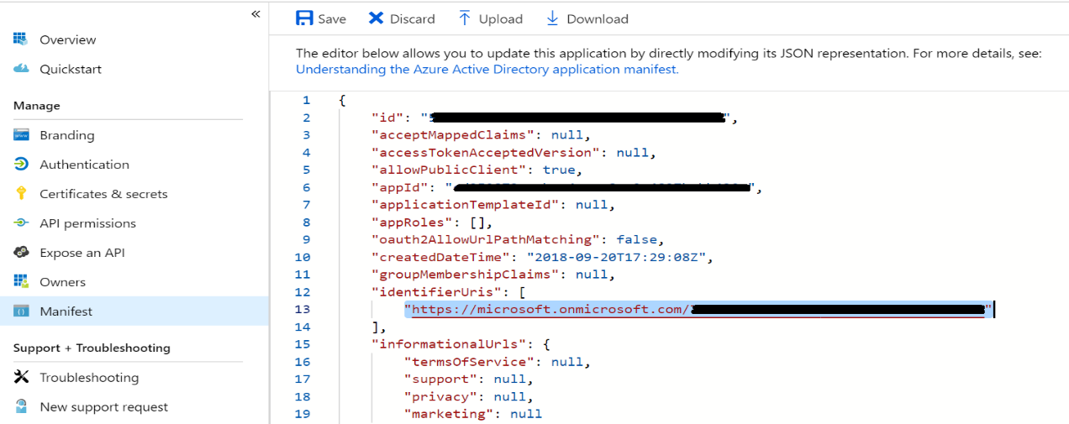

## Storage account creation

#### Go to Azure home page

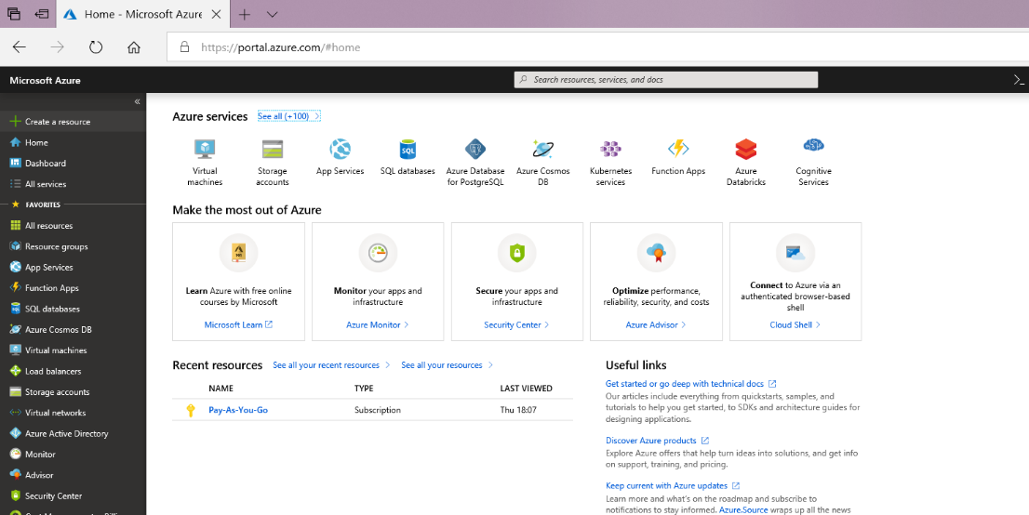

#### Go to create a resource

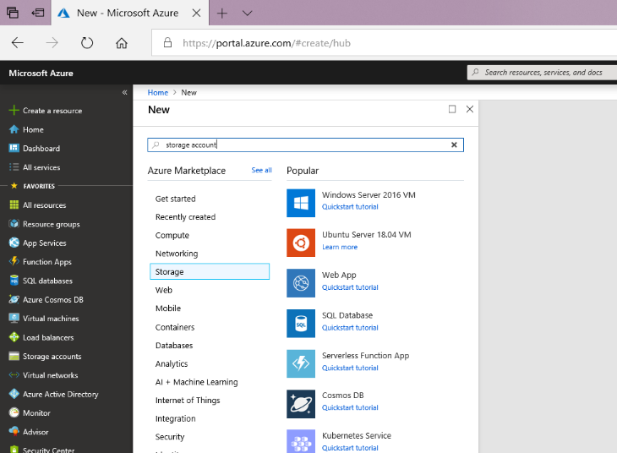

#### Select storage and click storage account

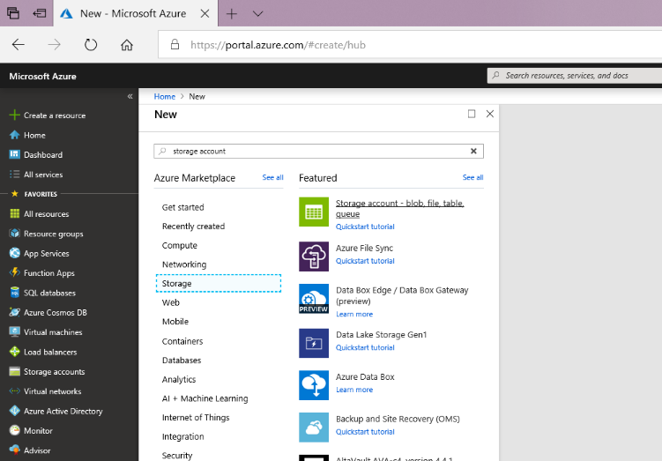

#### Create storage account

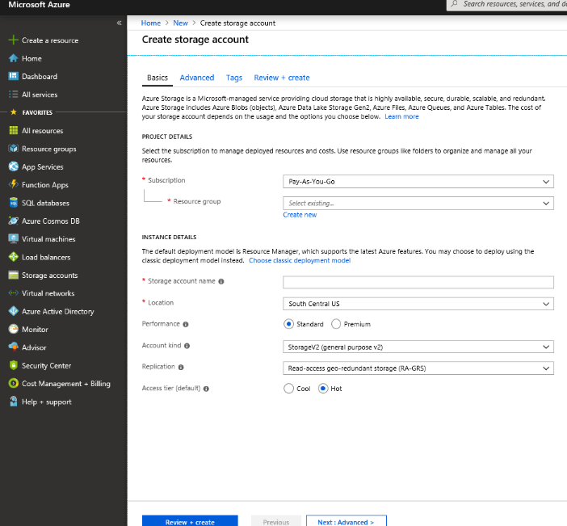

#### Select or create resource group

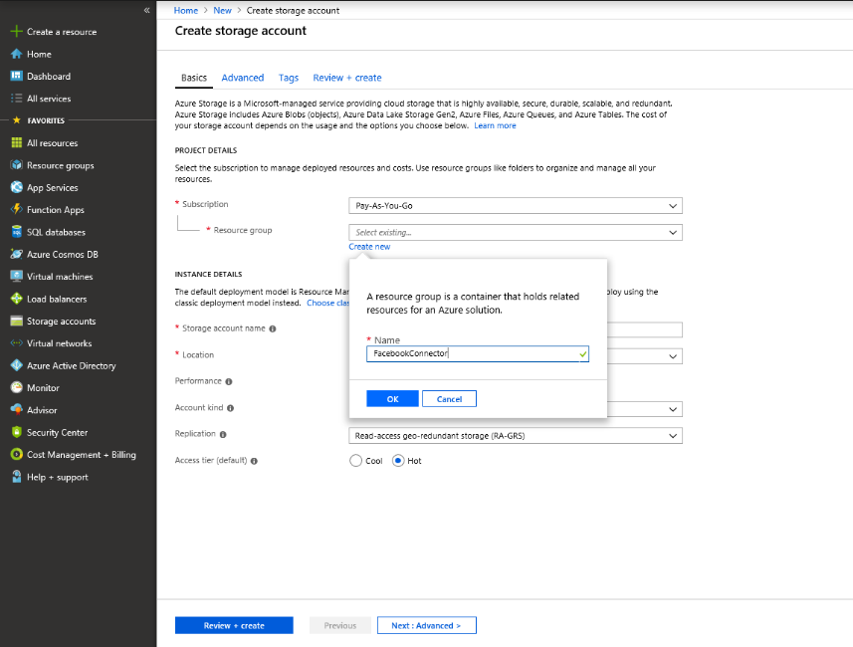

#### Provide storage account name

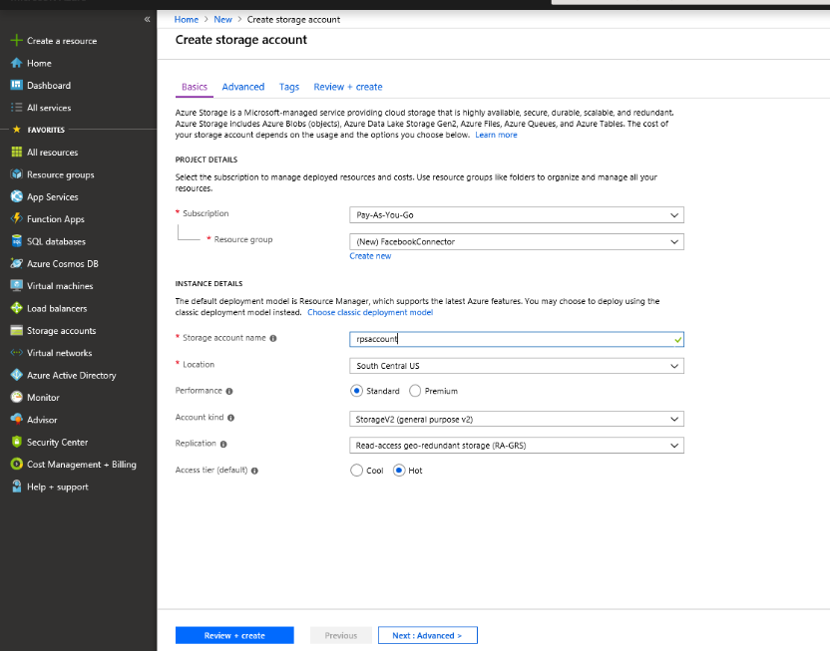

#### Verify and create resource

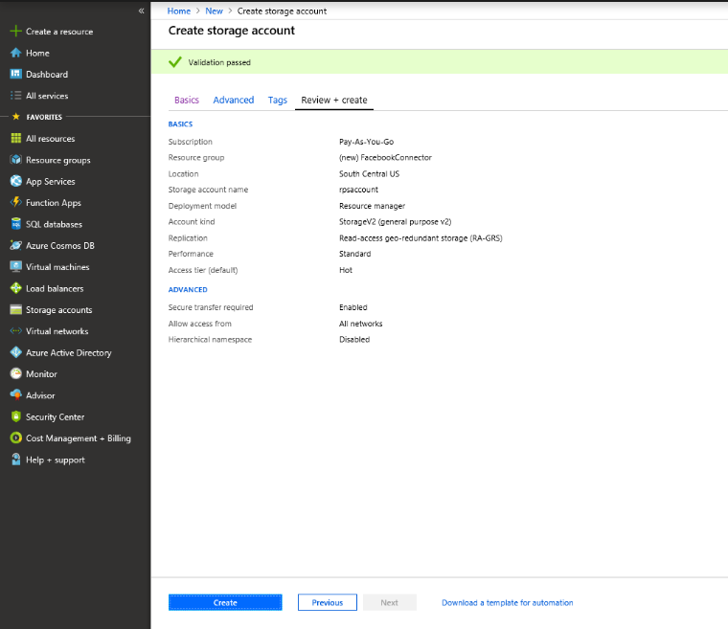

#### Go to the storage account resource

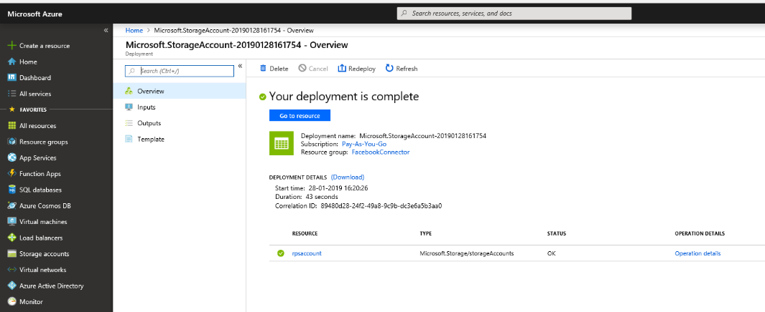

#### Go to access keys

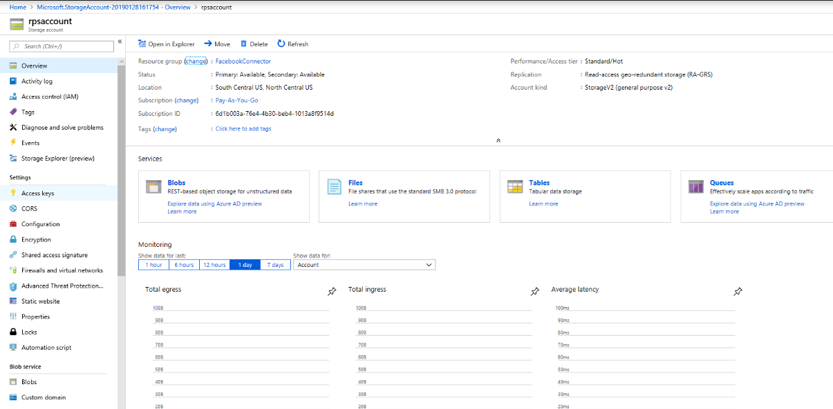

#### Make a note of the connection string

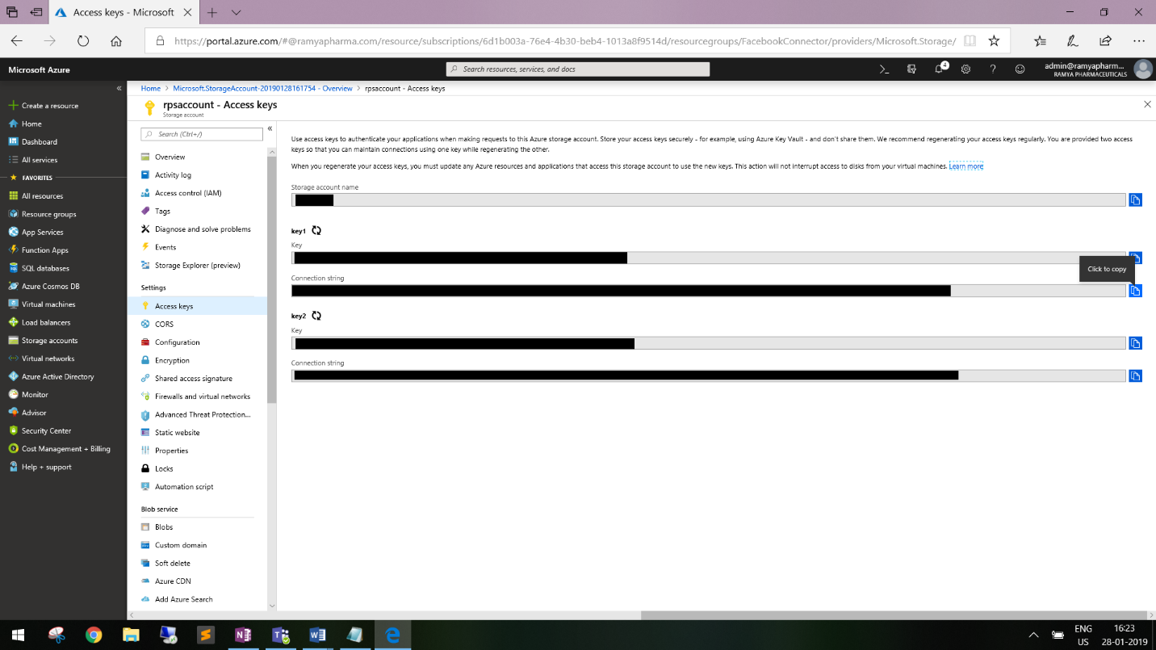

## App service creation

#### Create new Web App resource (App Service of type Web App)

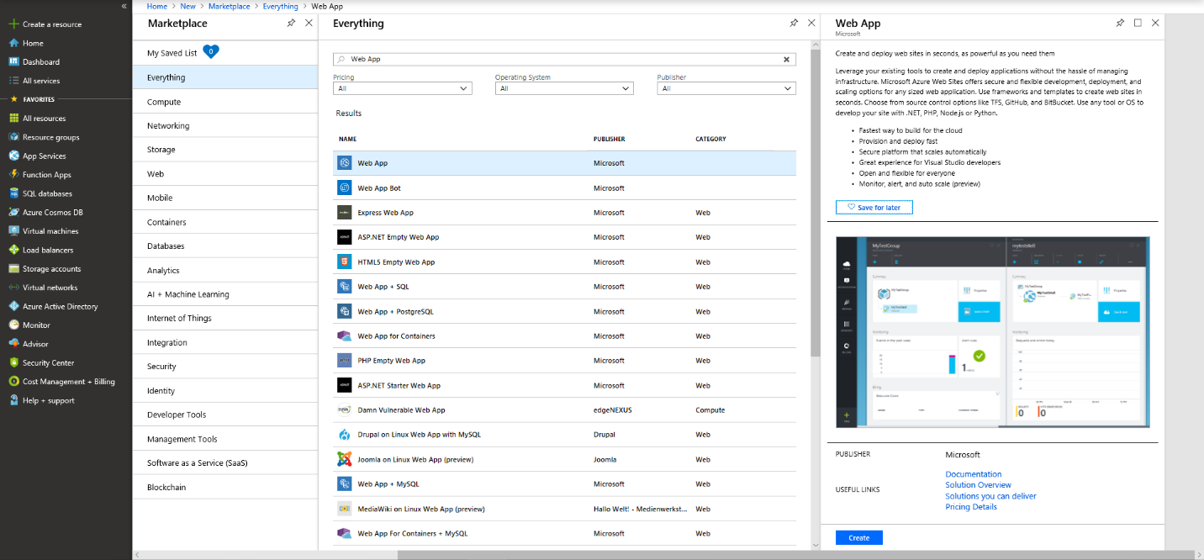

#### Fill the details as shown below and create Web App

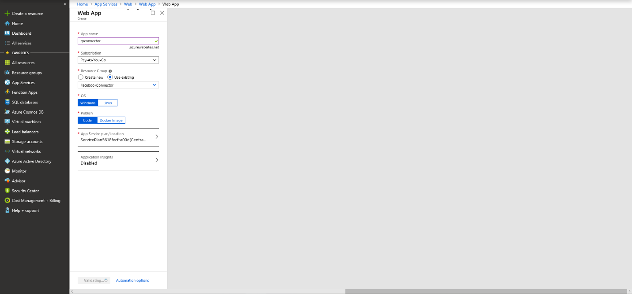

#### Go to the newly created Web App resource and fill all the settings as displayed with the values you noted above

Add the below 3 application settings with appropriate values

* APISecretKey – the seed password needed to configure the connector service
* StorageAccountConnectionString – value you have noted after you create storage account
* tenantId – your O365 tenant id

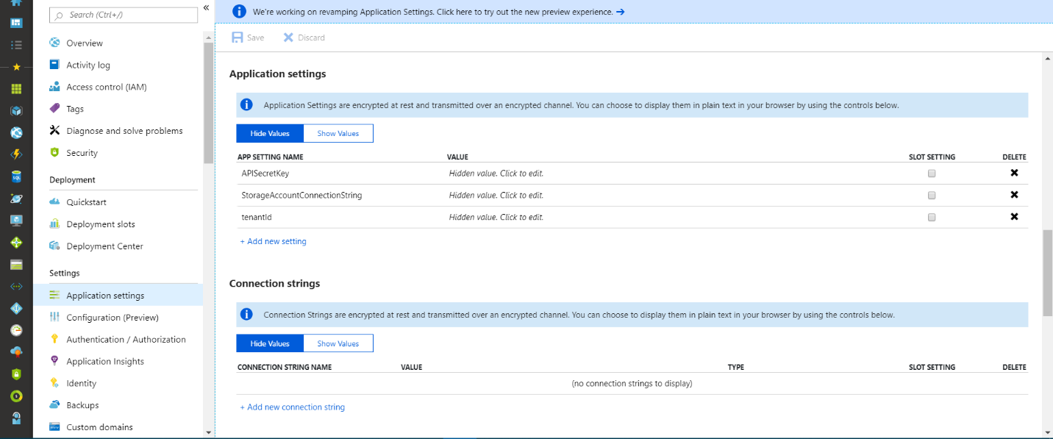

#### Turn the Enabled setting in Application Settings to Always On

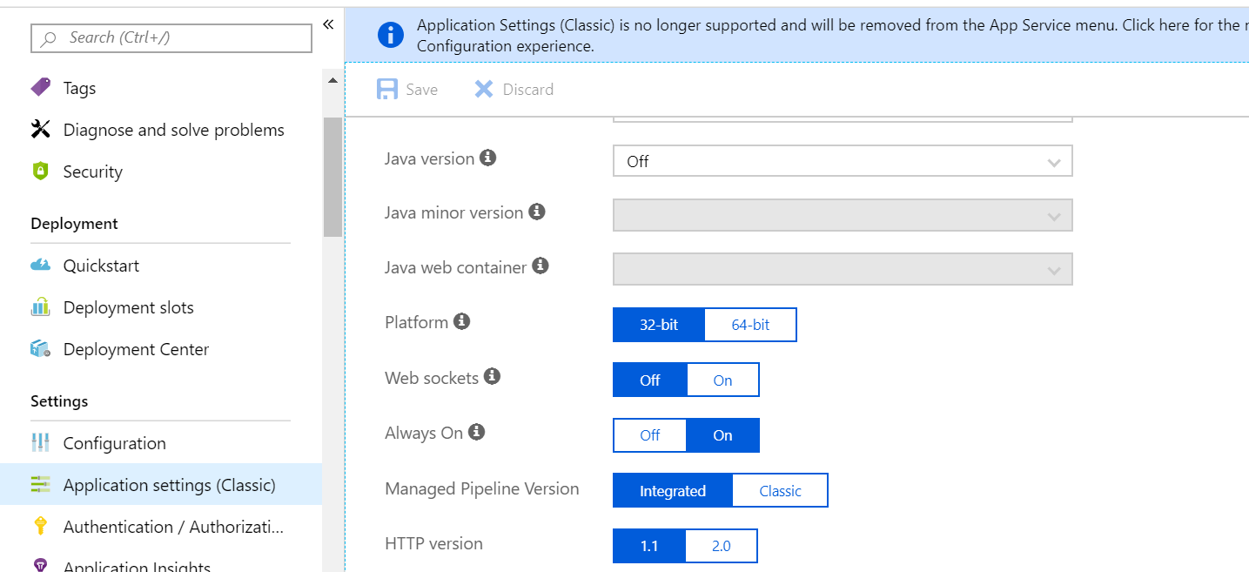

#### Upload the app service bits (zip file downloaded as mentioned above) using the below url

<AppService>.scm.azurewebsites.net/ZipDeployUi

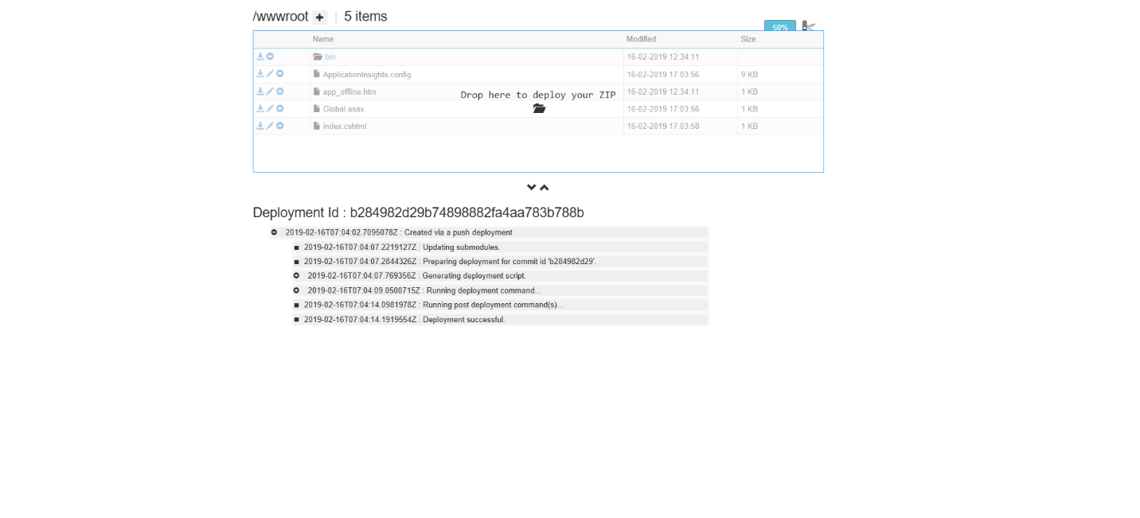

## Facebook App Registration

#### Add new Application

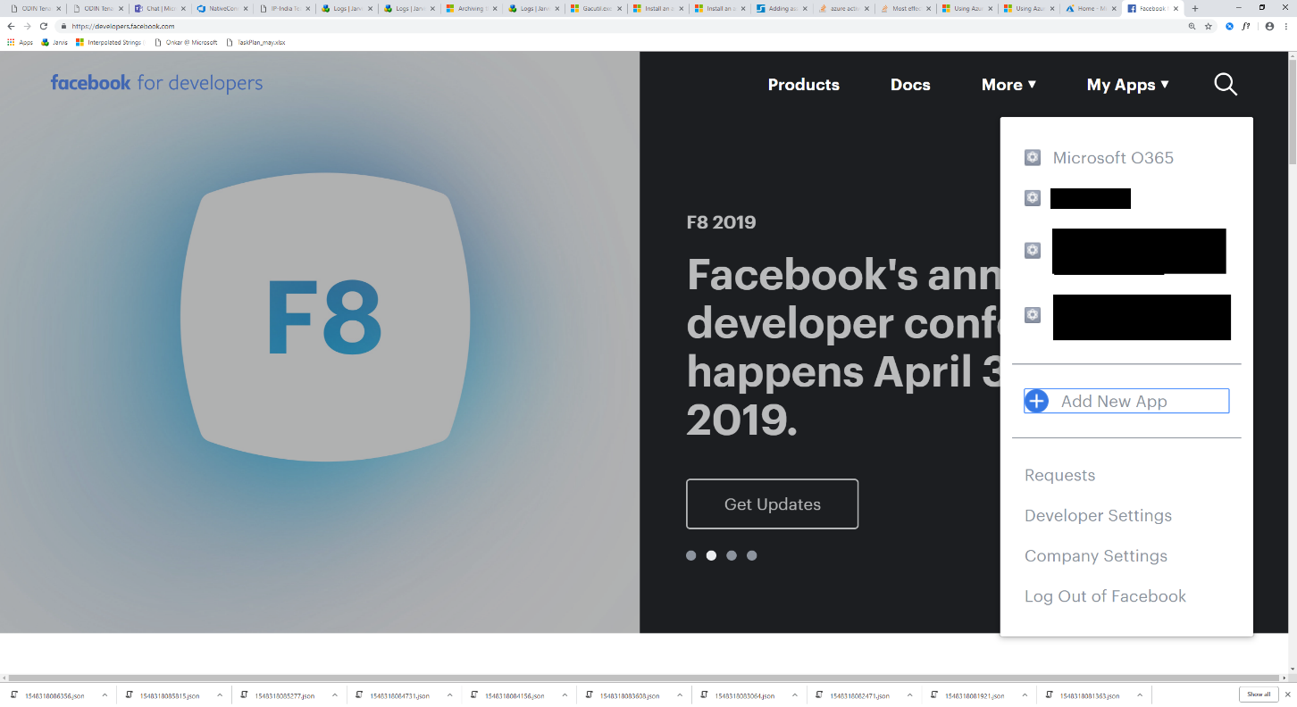

#### Create App ID

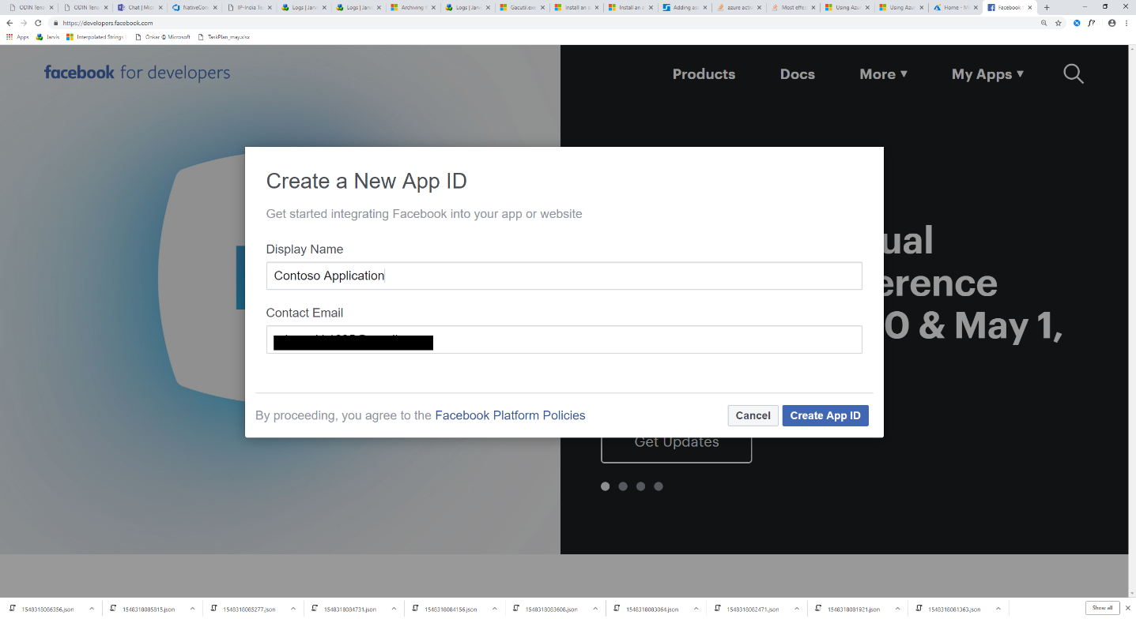

#### Add Products

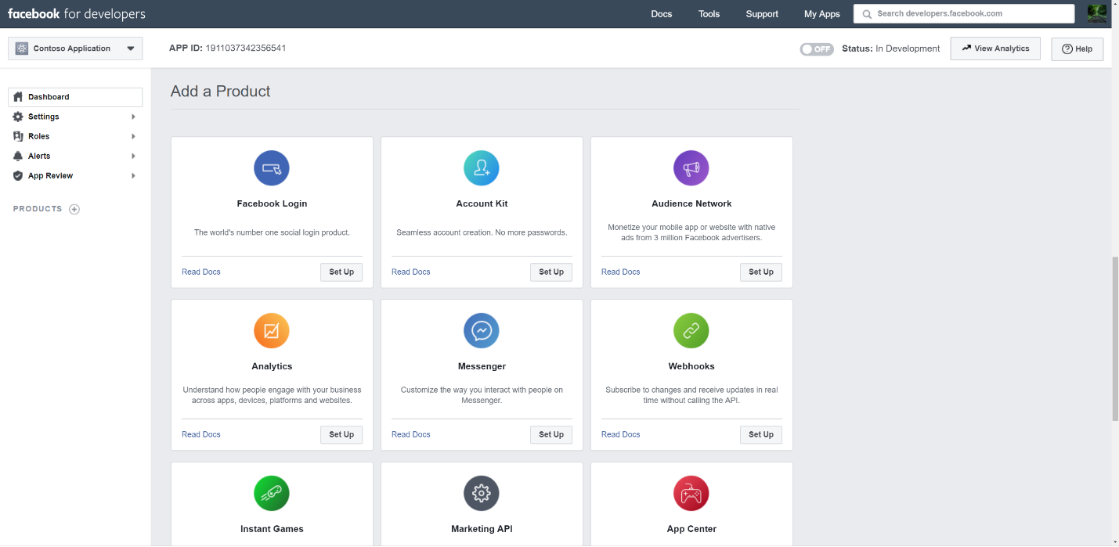

#### Integrate Facebook Login

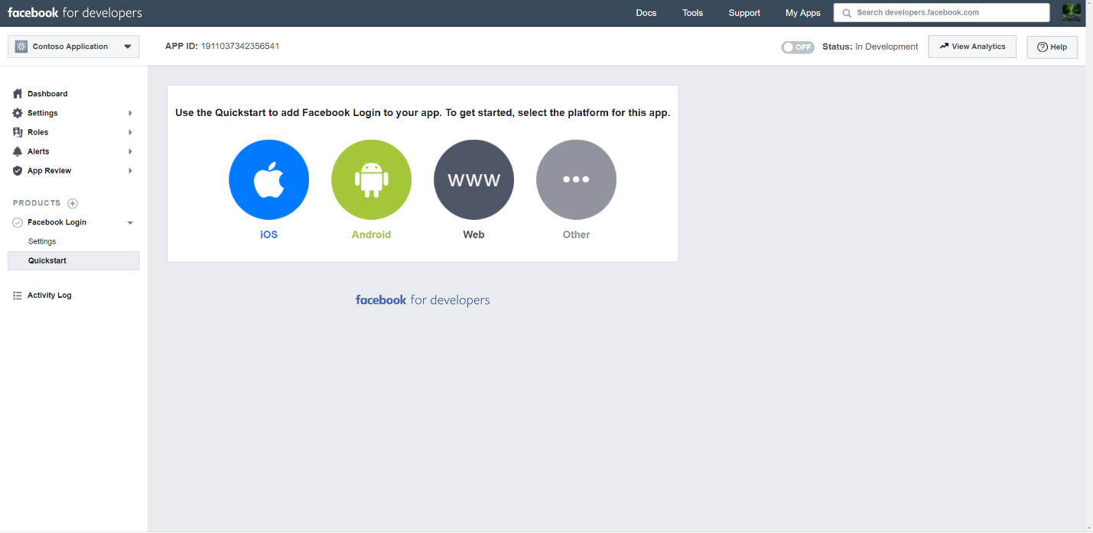

#### Add your hosted site URL

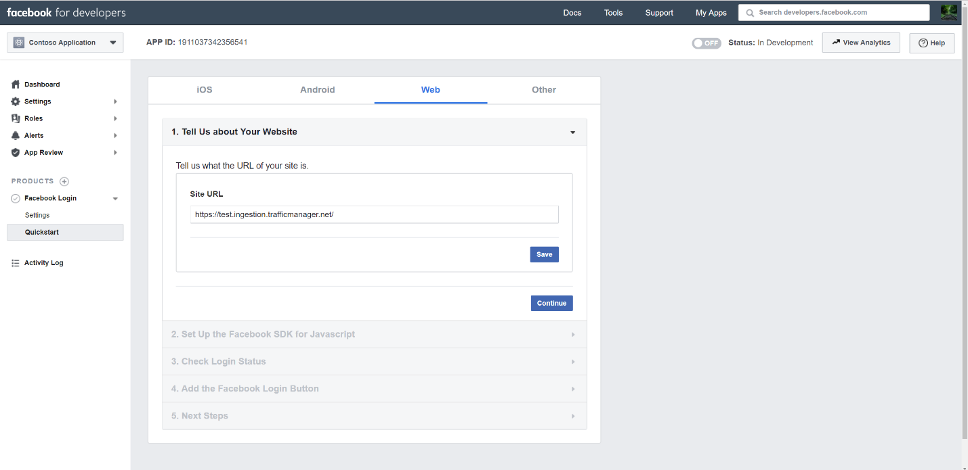

#### Completing QuickStart section of Facebook Login

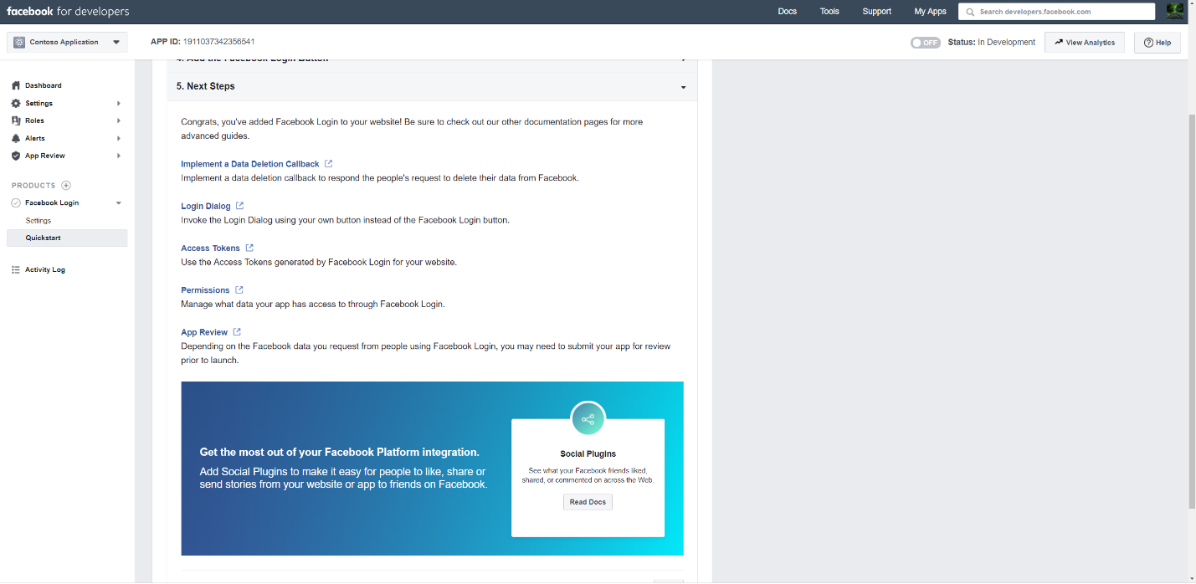

#### Add OAuth redirect URI <connectorserviceuri/Views/FacebookOAuth>

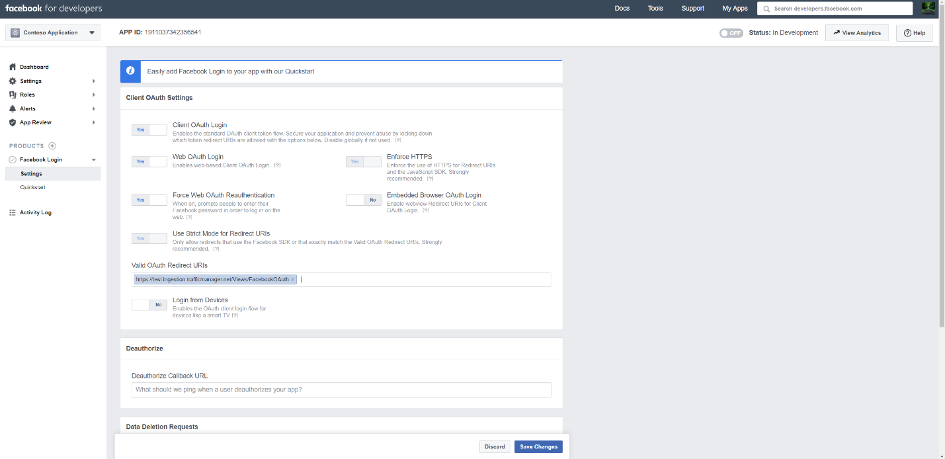

#### Setup Webhooks using Add products

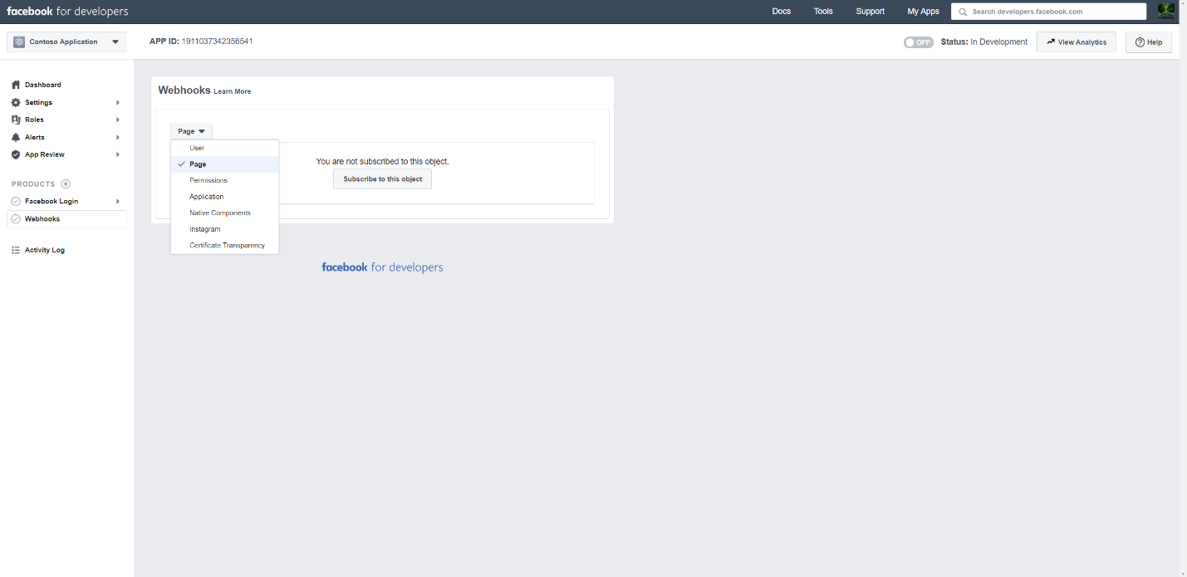

#### Add Webhooks callback url and add a verify token

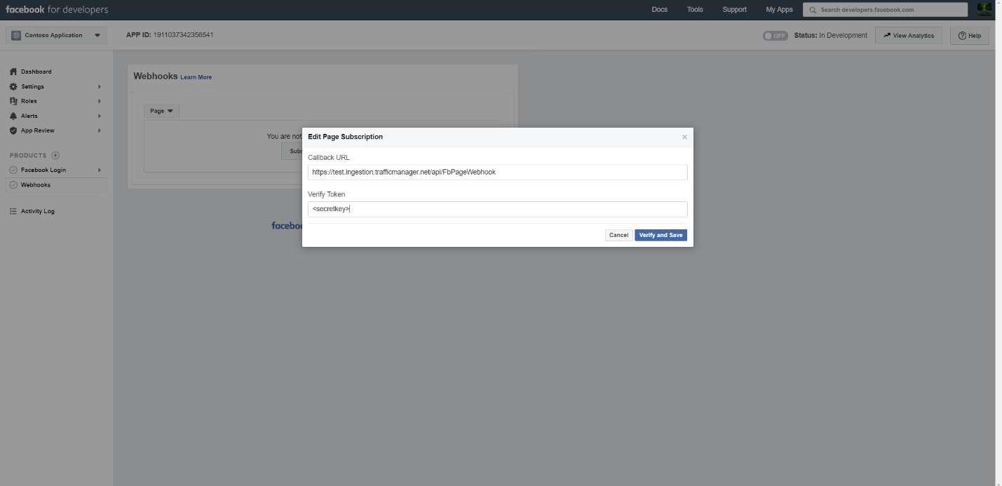

#### Test and Subscribe to the endpoint for feed

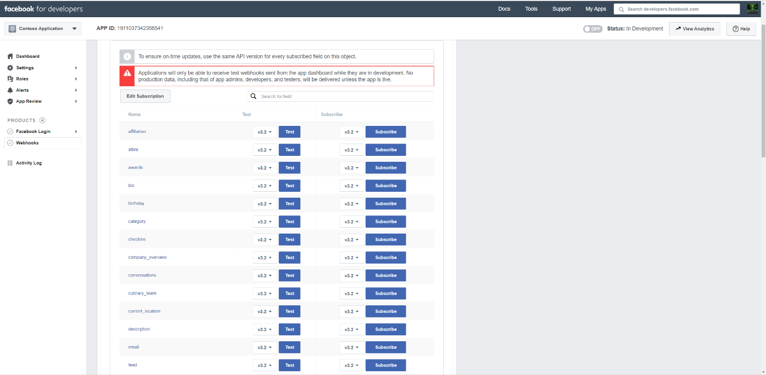

#### Add privacy url, app icon, and business use

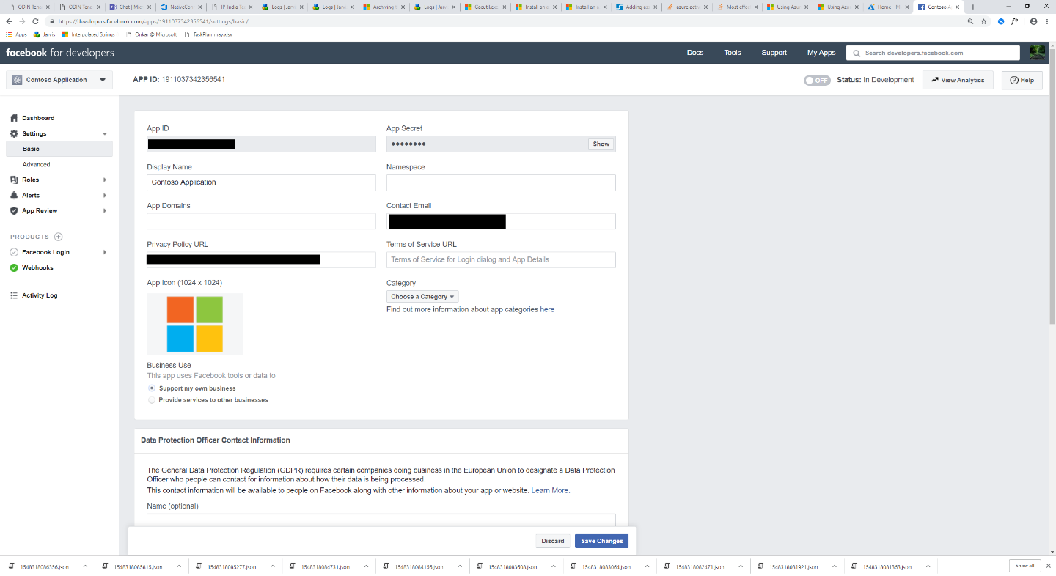

#### Make App public

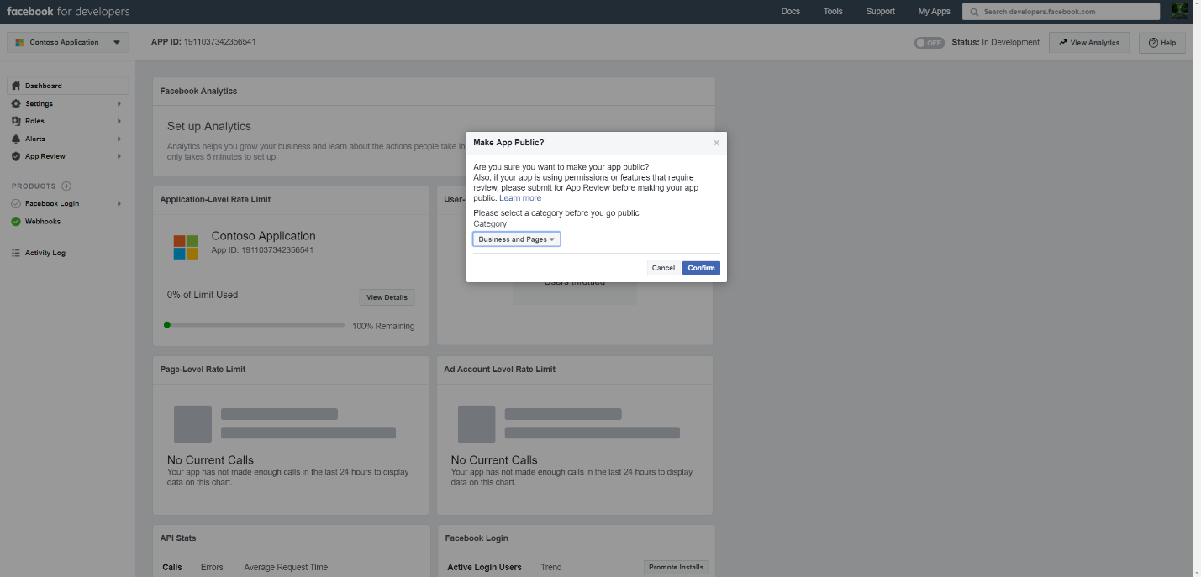

#### Add Admin or tester role for the user

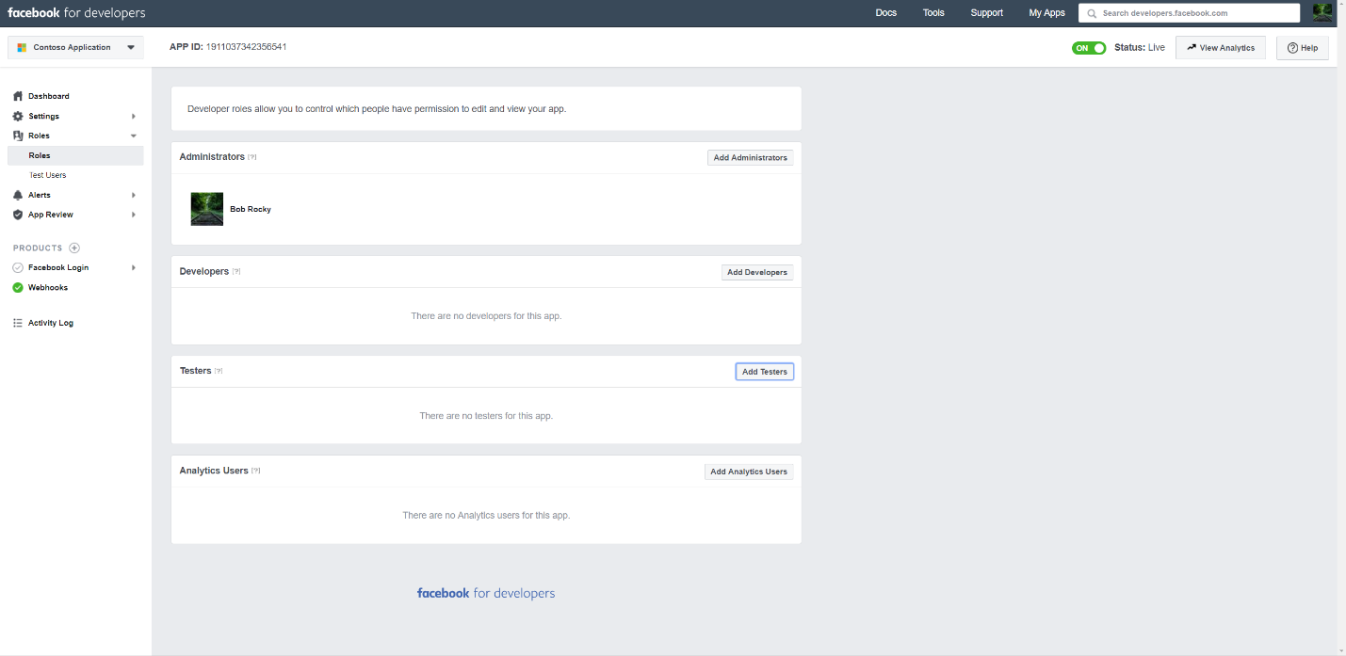

#### Add Page Public content access permission

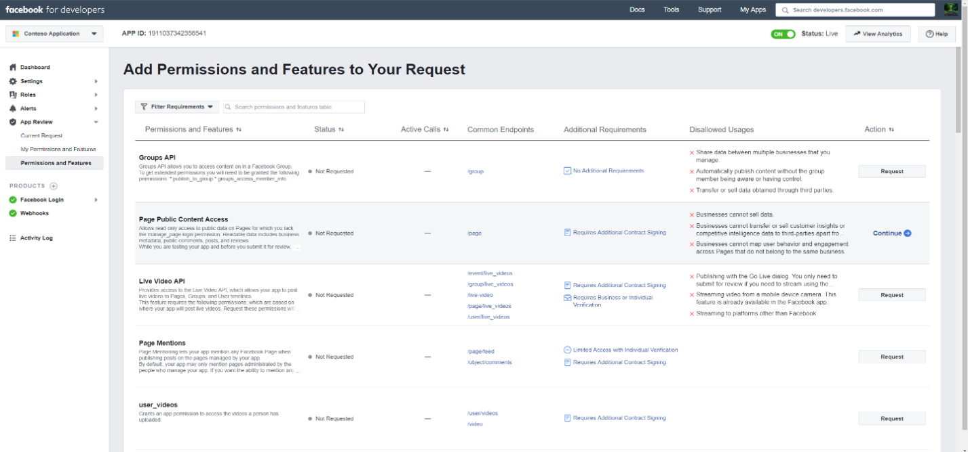

#### Add manage pages permission

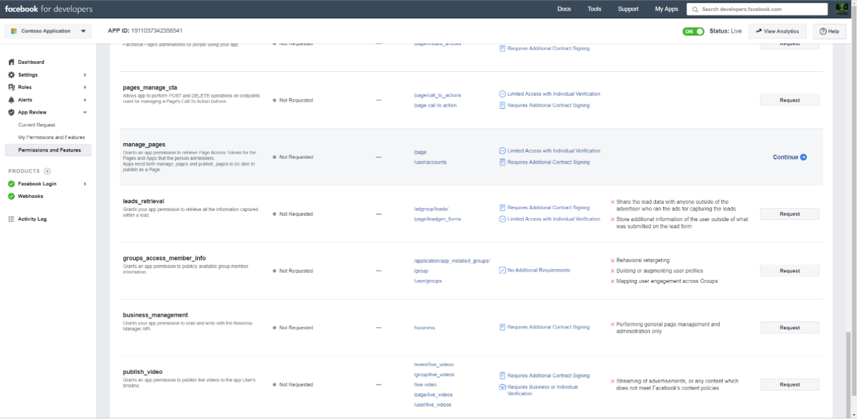

#### Get the application reviewed by Facebook

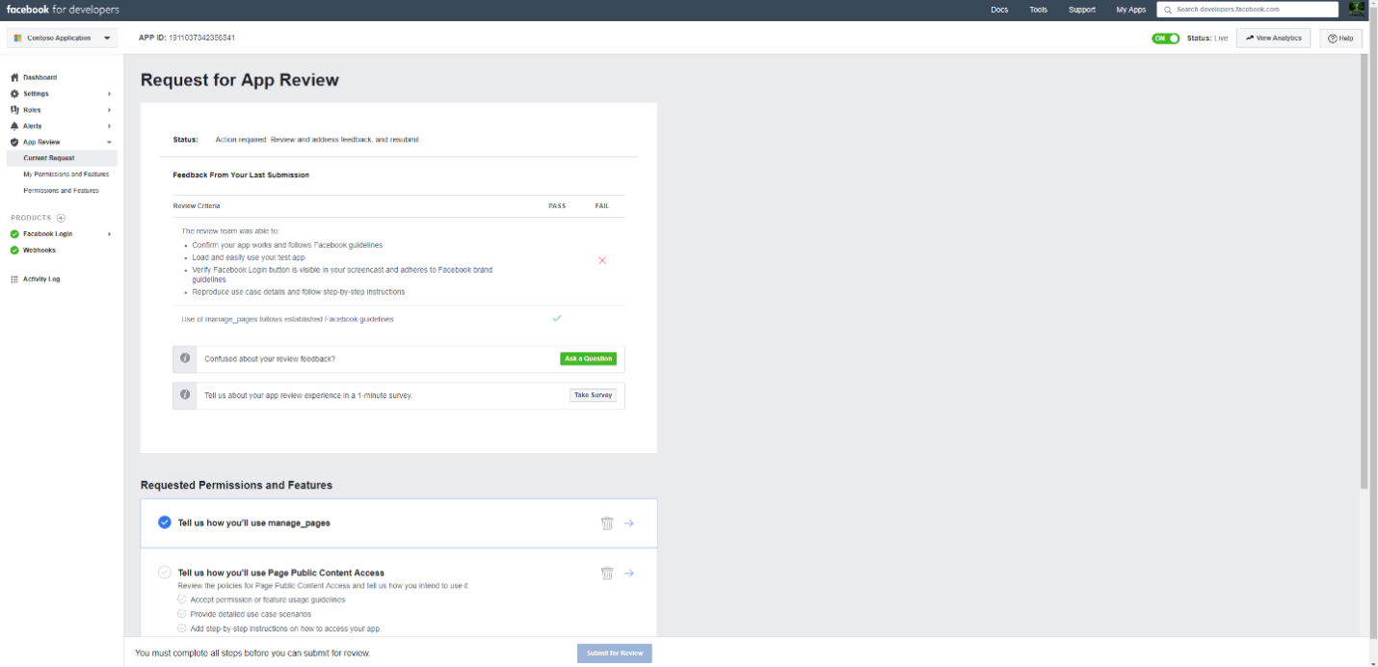

## Configure Connector

#### Configure the app service by clicking on the configure button on the home page of your app.

<appservice>.azurewebsites.net

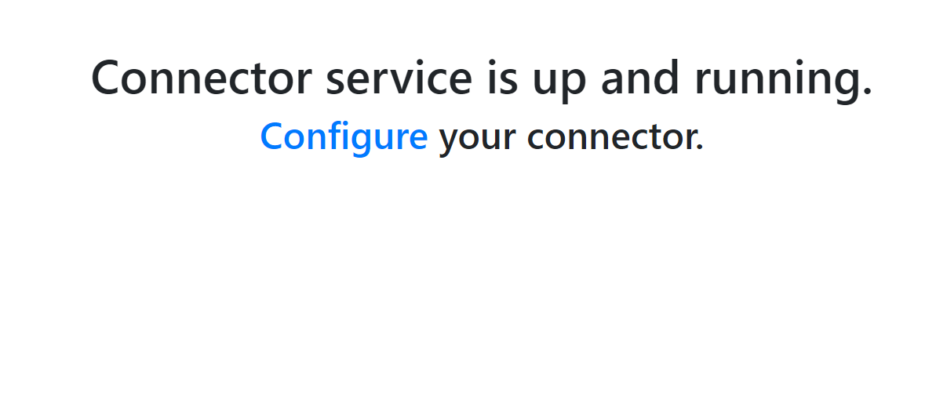

#### Login using Tenant Id and APISecretKey as set in the application settings

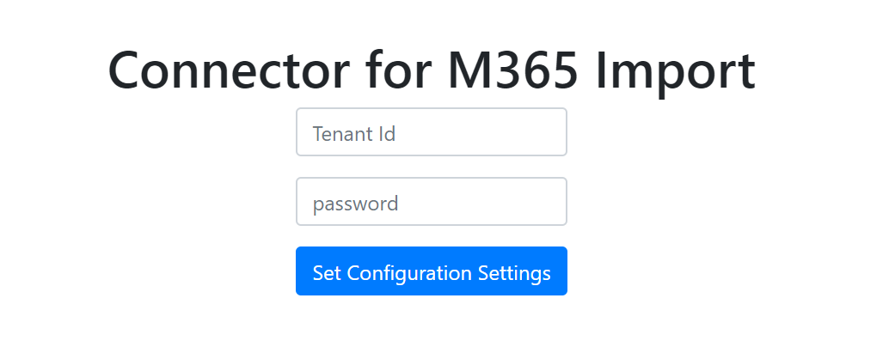

#### Set the configuration settings and click on save.

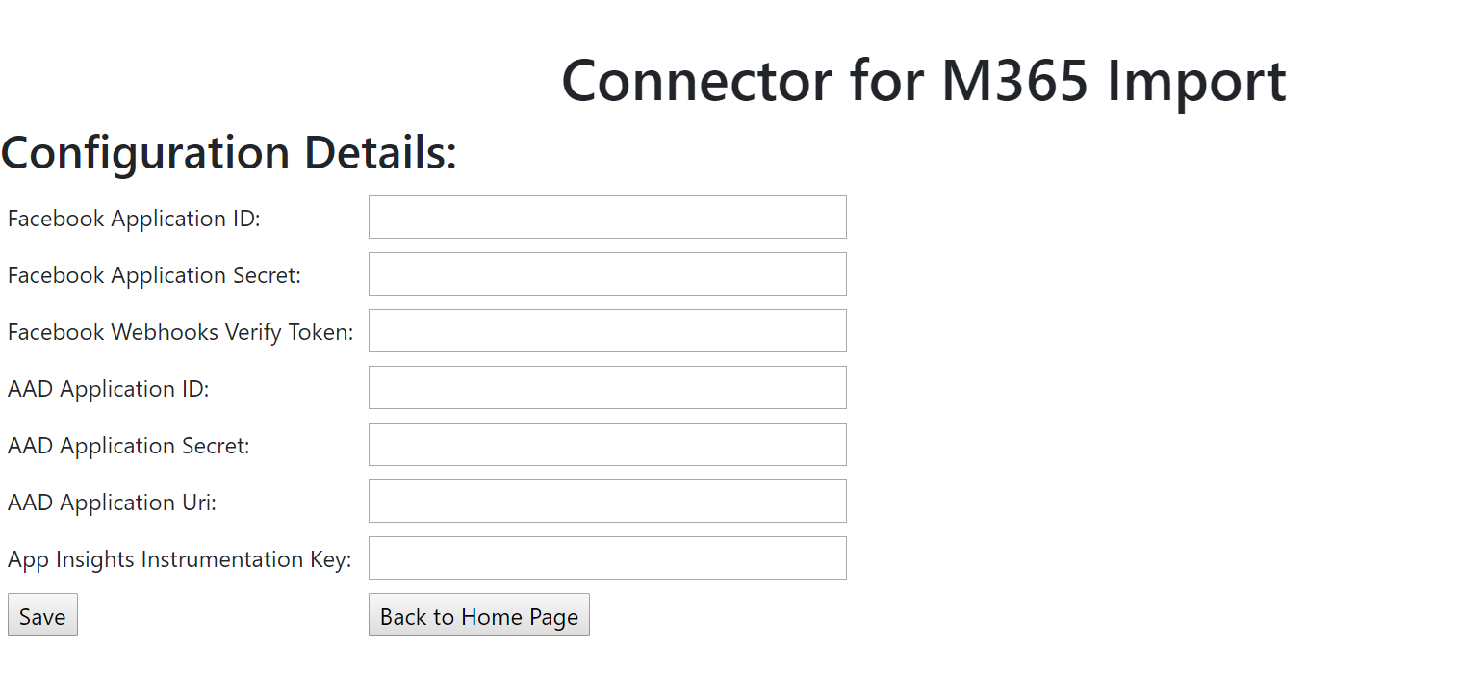

## Connector Setup in SCC

#### Go to Data Governance > Import and click Archive third-party data

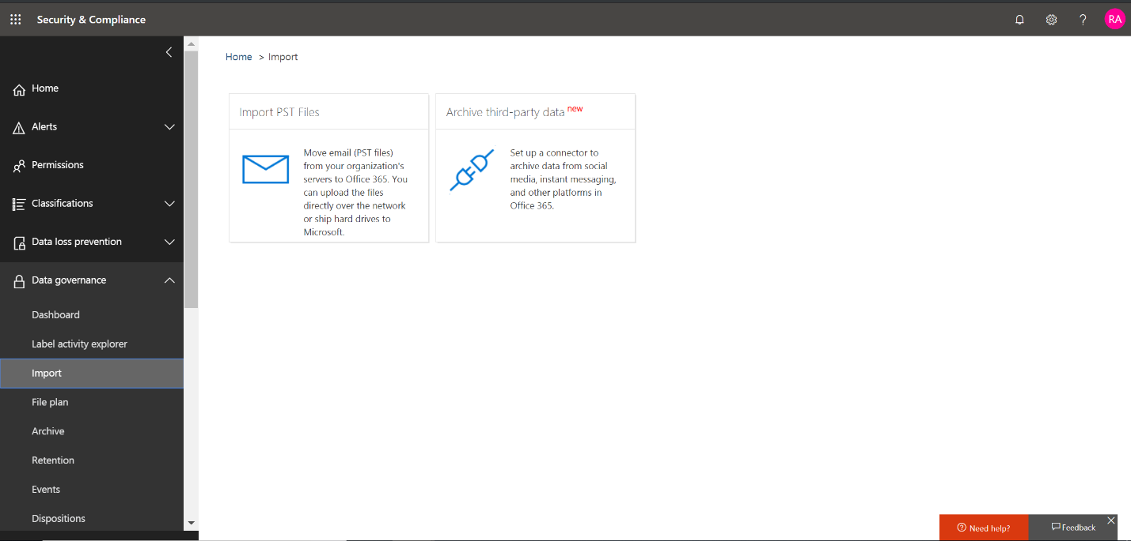

#### Click Add connector button and select custom

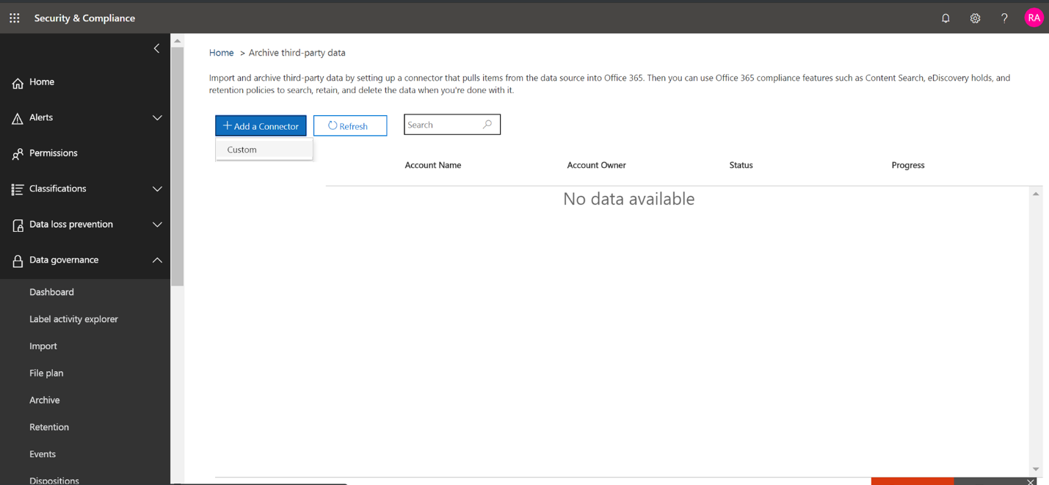

#### Provide Connector App details and click Next

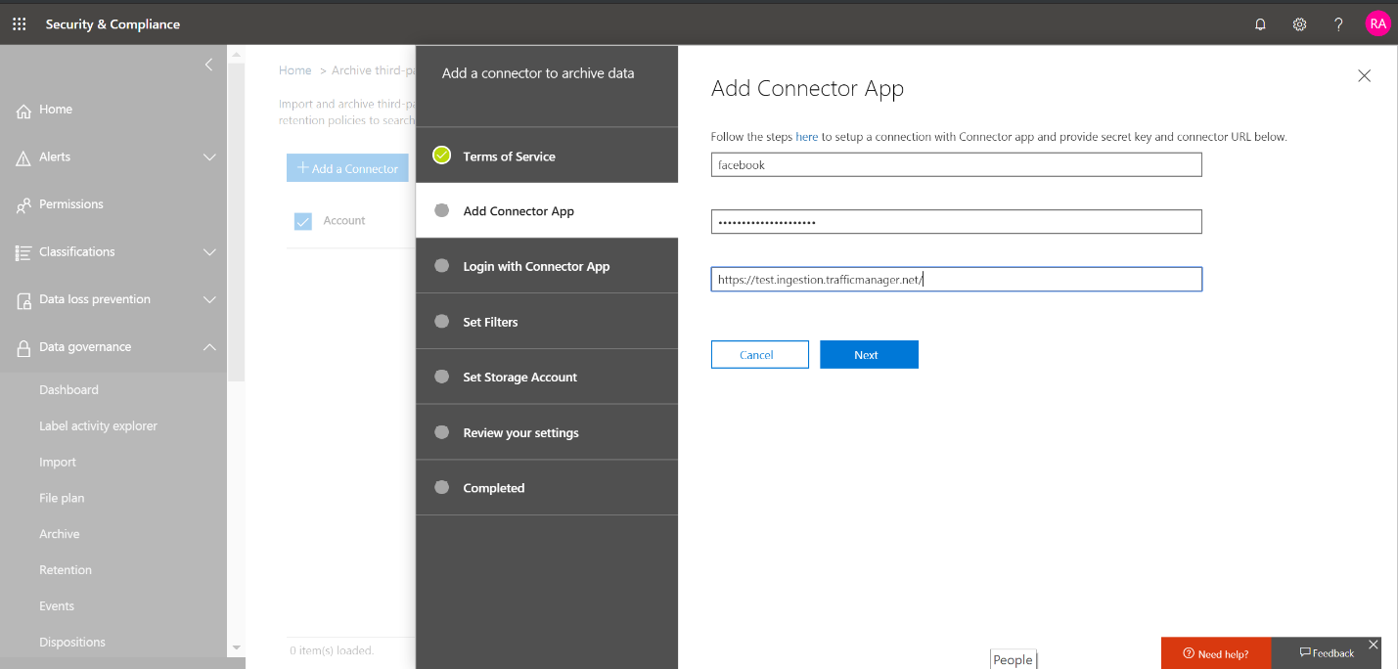

Fill the name as Facebook

Provide API secret key and connector URL as created in Finalize step 4

#### Click Login with Connector App

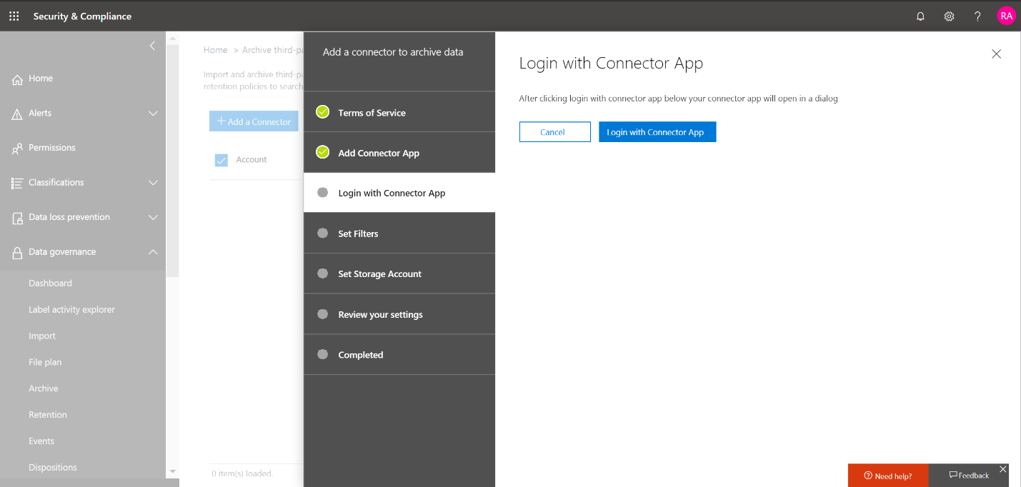

#### Provide secret and click login to connector service

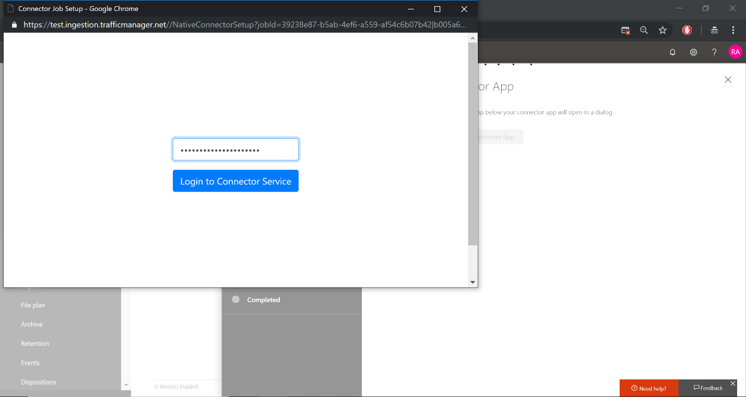

Secret key is same as the one entered in step above

#### Click Continue with Facebook

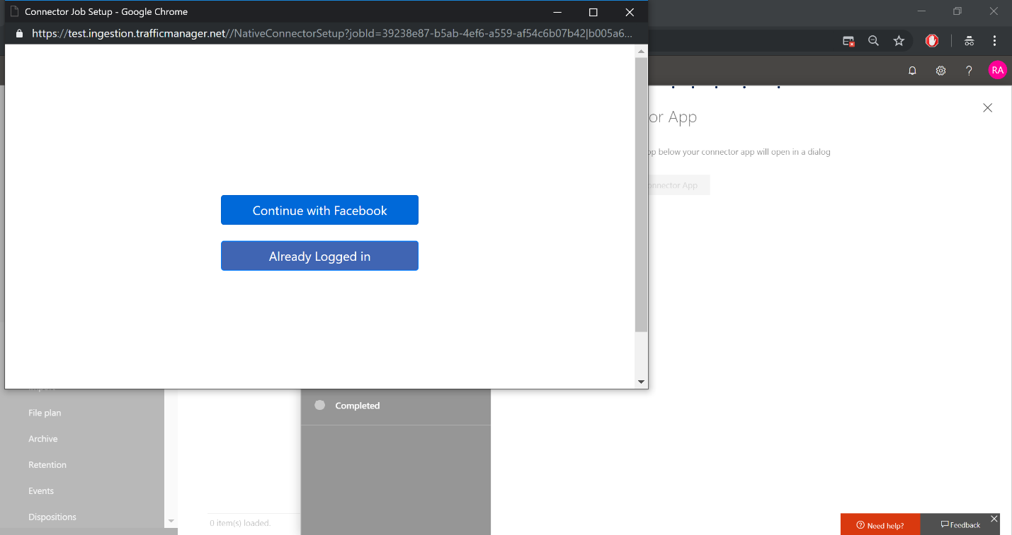

#### Facebook login dialog will open. Provide username, password and log in with Facebook. Make sure the Facebook account with which you log in has admin role to your company business pages

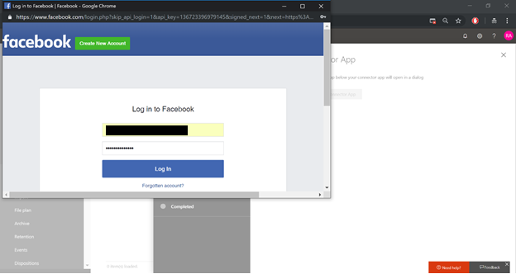

#### Click Select Pages to choose your company business pages you need to archive

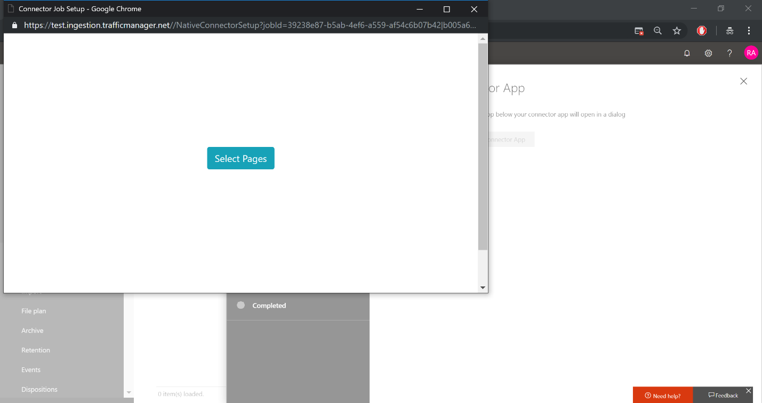

#### After you click Select Pages, a list of pages managed by your Facebook account will be displayed. Select the required page and click save.

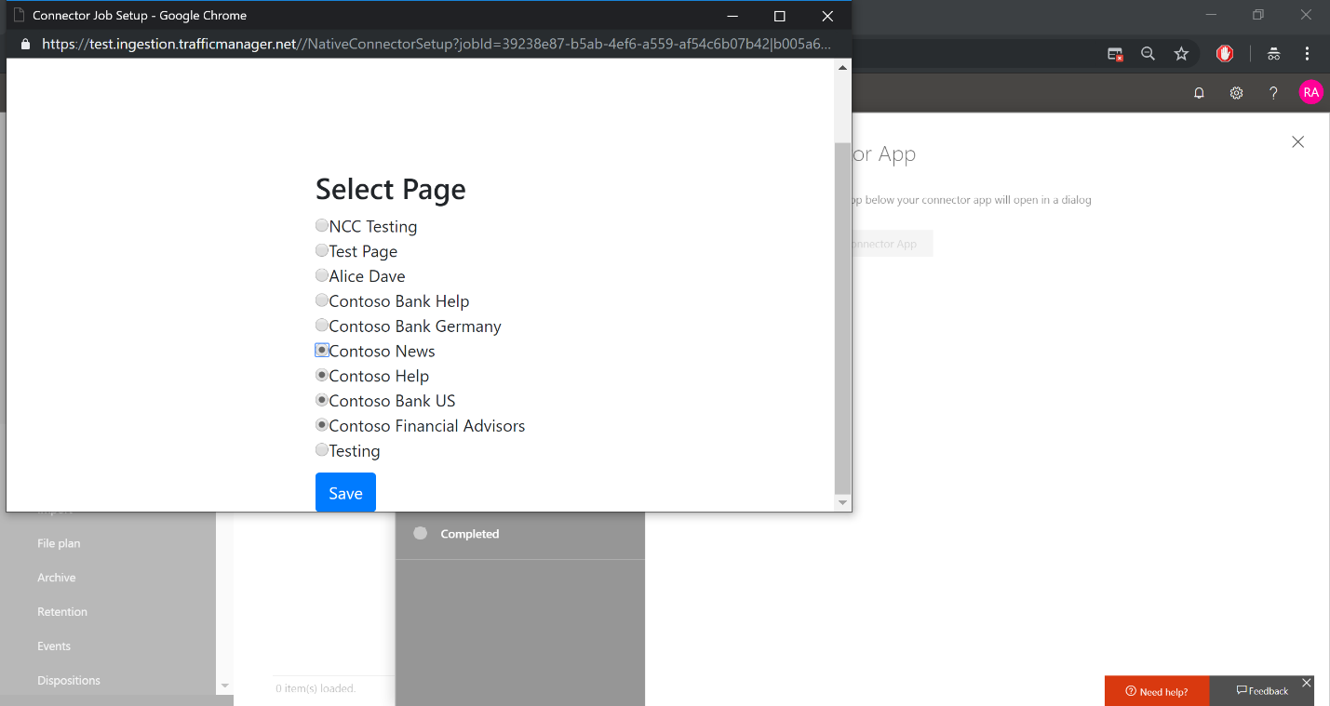

#### Finish connector service app setup

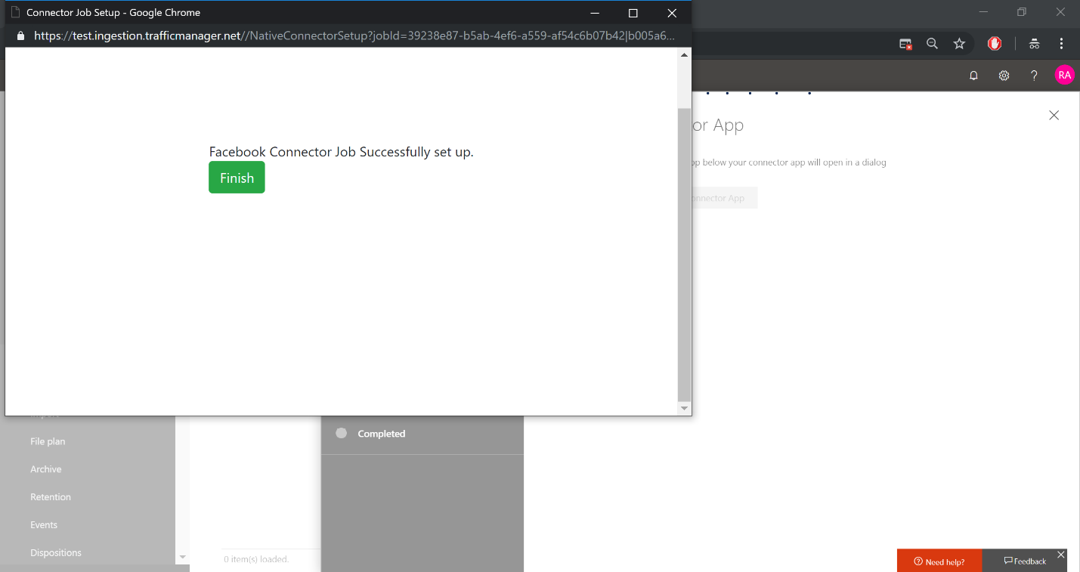

#### Apply filters. You can select the duration of data to bring in

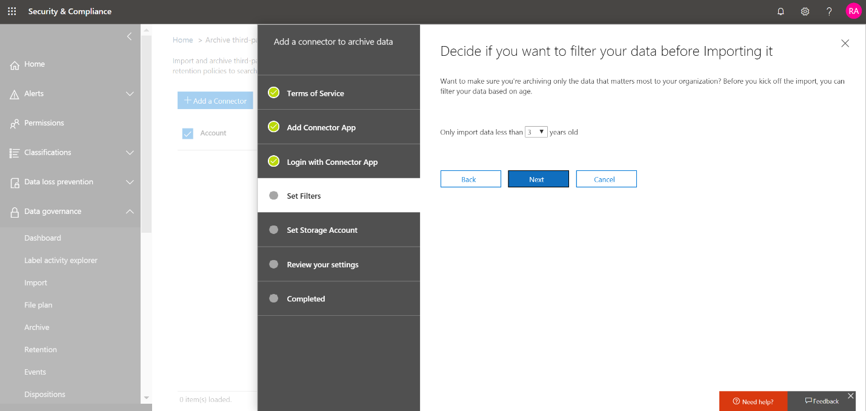

#### Specify user/mailbox to store Facebook data

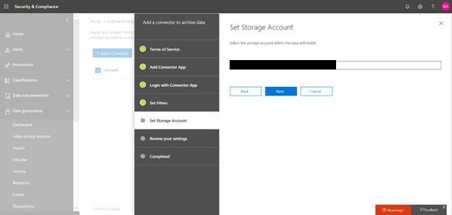

#### Review settings and finish connector setup

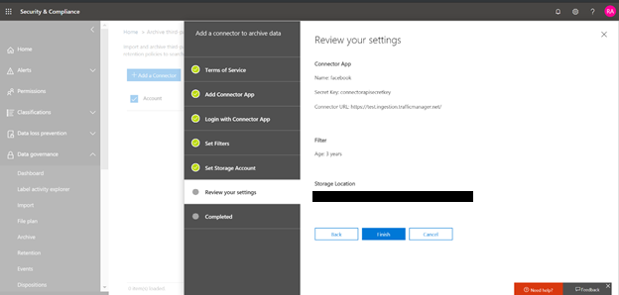

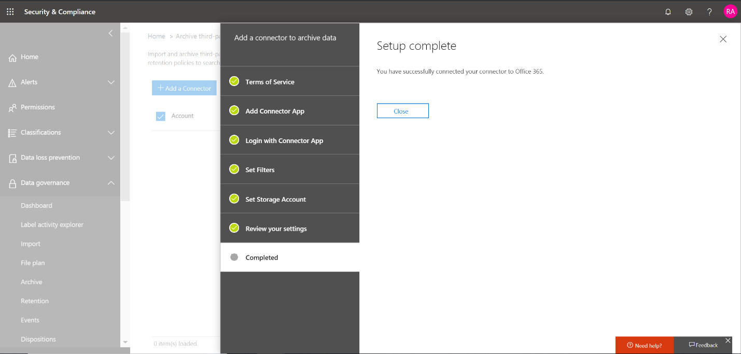

#### You can see the progress of import in the dashboard

